5.4.1 Conic Sections (Parabolas)

If a plane passes through a double right circular cone there are four possible resulting curves. These curves are the parabola, circle, ellipse, and hyperbola. These curves are called conic sections and are shown below.
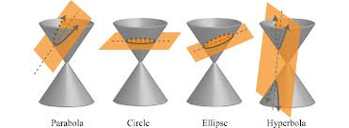

Definition: A parabola is the set of all points in the plane that are equidistant from a fixed line (the directrix) and a fixed point not on the line (the focus)

The Equation of a Parabola: (opening up or down)
The parabola
has focus
and directrix where and is the vertex.

Note: If then the parabola opens up. If then the parabola opens down.

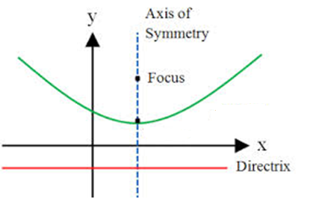
$$(h,k)$$
$$(h,k+p)$$
$$y=k-p$$

Developing the Equation of a Parabola


$$(h,k)$$
$$(h,k+p)$$
$$p$$
$$p$$
$$(x,y)$$
$$d_{1}$$
$$d_{2}$$
$$y=k-p$$

We see that

So

Example 1: Find the equation of the parabola with focus and directrix

Since the directrix is a horizontal line we know this is parabola that opens up or down.

Focus: so
Directrix: so

We solve the system and find, .

Therefore our equation is:

Example 2: Find the vertex, focus, and directrix of the graph of.

Since this equations shows y as a function of x we know this is a parabola that opens up or down.
Let’s first get our quadratic into vertex form by completing the square:

So

Vertex: Focus:
Directrix:

Example 3: Find the vertex , focus, and directrix of the graph of.

Since this equations shows y as a function of x we know this is a parabola that opens up or down.
Let’s first get our quadratic into vertex form by completing the square:

So

Vertex: Focus:
Directrix:
The Equation of a Parabola: (opening left or right)
The parabola
has focus
and directrix where and is the vertex.
Note: If then the parabola opens to the right. If then the parabola opens to the left..
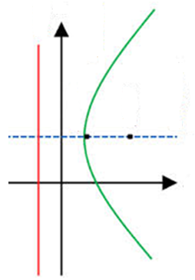
$$(h+p,k)$$
$$(h, k)$$
$$x=h-p$$

Example 4: Find the vertex, axis of symmetry, y-intercepts, focus, and directrix for the parabola . Sketch a graph of this parabola.

Since this equation shows x as a function of y we know this is a parabola that opens left or right.
Let’s first get our quadratic into vertex form by completing the square:

So

Vertex: Focus:
Directrix: Axis of Symmetry:
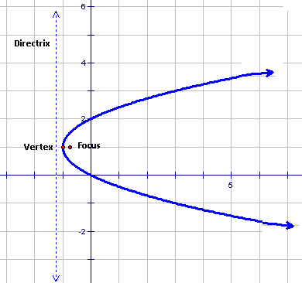
y-intercept(s) will occur when .

y-intercepts:

